Day 1

Oddly, I felt nostalgic, as we hovered over Belize. The greenery and the beautiful simplicity is similar to Nicaragua. I felt as though the smoke rising to the air from the mounds were signals that were greeting us and guiding us.

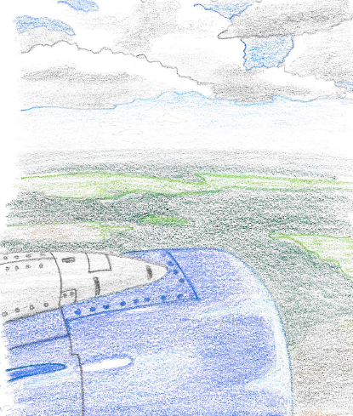

Artist from Belize
-Chelsea Johnston 22 years old.
Chelsea is a painter, but has a phobia of painting. She overcame her phobia through painting classes.
-Mike Berber
Labeled himself as a new artist on the scene. He still feels as though he is trying to figure out painting. Did not paint as a child. Currently his works vary in style. Ex. Modern, Pop Art, Abstract Art. Berber spoke of the hardships as an artist and the economic struggle. 6 or 7 jobs to thrive in Belize.
-Kevin Balazar
Balazar has 10 years of banking experience. Originally was studying to be a doctor or engineer. He took a leap of faith, as he felt he needed to prove to himself that he truly is an artist.
-Gayla
Gayla’s journey as an artist is one of self-discovery. Although she has been on this path, she revealed that she is still searching for herself. She is interested in topics of abuse and focuses on women. Does portraits of women, to capture the emotions, the eyes are the window to the soul.
-Ilona Smiling
Smiling is interested in modern art; she desires to push that genre in the art scene in Belize. This is also the primary reason that she chose art museum field. She is curious and questions why we compromise the way we see things, on issues of principles and moral. Ms. Smiling was very honest and opened up on the struggles the artists face in Belize.
- Art is not recognized or widely regarded in Belize
- Little to no opportunities
- Art is considered a hobby
- No art collectors
- Conceptual art is almost non-existent
- Rift in the art community

I was surprised that the Belizean artist dealt with the same issues we face here in Miami. Issues of racism, gender, domestic violence, gun violence, and lack of support from the government, etc. Although I was in a different country, at the same time I felt as though I never left.

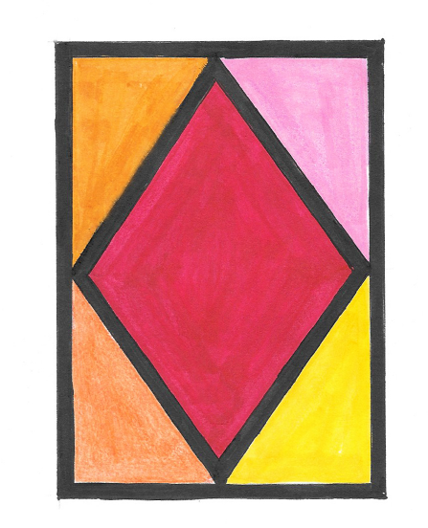

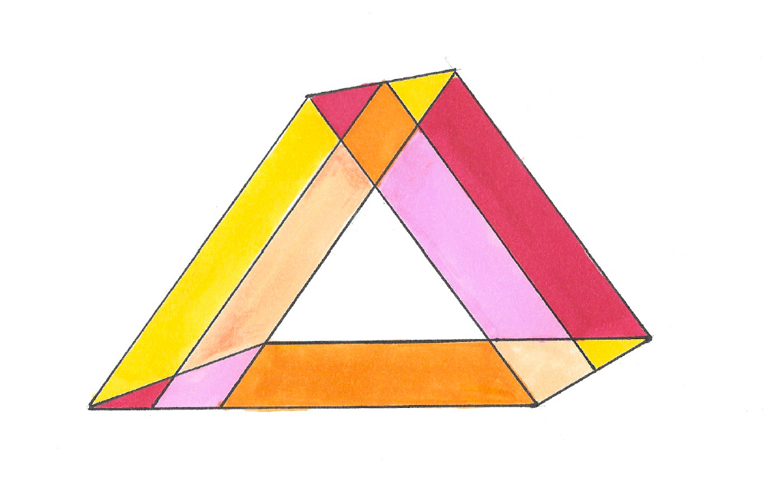

Image Factory
Founder Yasser Musa, mentioned there is a river behind the building and that with a boat one can take the river to go into Belize (and Out). I understood that the location of the gallery has special meaning in terms of Musa’s global vision for the Image Factory. Image factory has thrived for 25 years, and has published over 200 diverse exhibitions.

Image factory Artist Katie Numi
Katie spoke highly of the Image Factory, as they have provided her with the space to execute ideas against sexism, classism, ageism, etc. She works from a place of urgency, disrupting and agitating the body, and the body becomes the medium. She is a conceptual and social activist artist.

Yaolin is another Image factory artist.
She enjoys Plein air painting. The sea-scape, cityscape – to feel it. Yaolin abides by a rule, if it is overworked it is not fresh anymore. She looks for light in everything. A philosophical view that aligns with her art and life.

Global Space
Glocal Space
- Yassar Musa

Nurturing is important, not only for the artist but for art collectors as well.

Topics of sustainability for artist:
-Need to foster art
-Create a culture of culture
-The importance of a connector- a bridge between artist and collectors.
-Need to elevate creativity
-Space of inclusion for curators and critics
-Be prolific
-Art should be a ritual
-Make art because that is who we are.
-Must look at art and scholarship
-Critics and dialogue amongst ourselves.

Topics continued:
-What are we reading? What kind of books?
-Making non-traditional art? Find creative ways to document work.
-Education is of the upmost importance
-Have sessions to close the gap between each other
-Studio visits are a must!
-High art, low art – these labels hinder the Caribbean
-All art should be seen through the same level of respect and delicacy
-Trade art
-Race is an issue- get it together.
-Labels can create divisions, and unfortunately success can also drive people apart.
-Size of work is secondary, it is all about the content. It should be visually powerful.
-Collaborate with local artists
-Spoken Word – 501, poetry group.

